Frontend Design
The front-end design of Job Radar aims to be simple, user-friendly, and visually consistent. Since the platform targets both job seekers and employers, we want users to quickly find the content they need without feeling overwhelmed by information overload.

To achieve this goal, we have adopted a clean, modern design across the entire platform. Different pages use consistent colors, fonts, buttons, and layouts, allowing users to easily navigate the system and become familiar with its features. In addition, important action buttons such as search, login, and registration use prominent colors to attract visual attention, helping users quickly identify key actions.

We also focus on improving the efficiency of the search process. Users can search using keywords and apply various filter criteria to narrow down results, enabling them to find suitable jobs or candidates more quickly.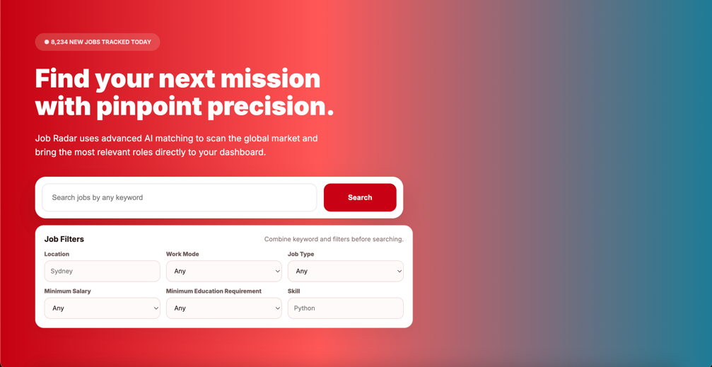

The Job Radar platform uses the Inter font throughout the website. We chose this font because it is clean, modern, and easy to read on different devices and screen sizes.

Different font sizes and weights are used to help users quickly understand the importance of different information. Page titles and section headings use larger and bolder text, while descriptions, labels, and other auxiliary content use smaller text.
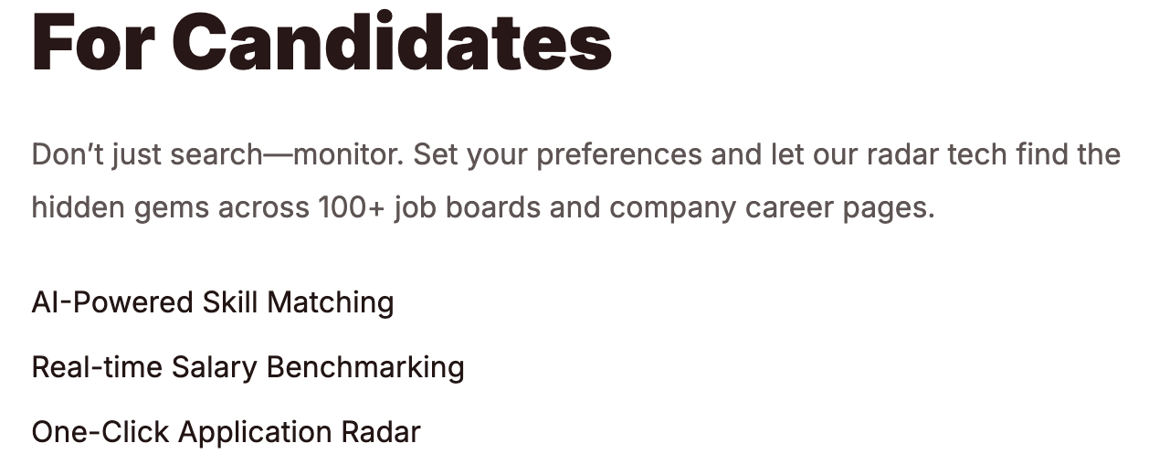
By keeping the typography simple and consistent across all pages, users can browse the platform more comfortably and find important information more easily.

The color scheme of Job Radar is designed to create a modern and professional look while keeping the interface visually appealing and easy to use. Red (#FF3B30) is used as the platform's primary color, mainly applied to the logo, important buttons, and key interactive elements to attract user attention and encourage user actions. Yellow (#FFCC00) is used to highlight important information, such as recommendation scores and VIP-related features. Blue (#0094BA) is used as an accent color to provide visual balance, making different parts easier to distinguish. At the same time, neutral brown-gray (#8B716D) is used for text, labels, and other supporting content to maintain readability. By using a consistent color scheme across all pages, the platform achieves clear visual recognition while ensuring that users can easily identify important information and navigate the system efficiently.

In the process of page design, we have always adhered to a core concept: clearly distinguishing between the two main types of users on the platform — job seekers and employers. Since the goals and needs of these two types of users differ significantly, we have designed different homepages, profile pages, and functional interfaces for them. This design allows users to immediately understand the page and identity they are currently on upon entering the system, and quickly access the most relevant features. By designing interfaces tailored to different user groups, the platform can provide a more personalized experience, while also enhancing overall usability and efficiency. Overall, we hope that every user of Job Radar can experience convenience, comfort, and clear operation throughout their usage, thereby completing job searching or recruitment-related tasks more efficiently.
